**Major Activity**

* Write SQL commands that **capture specific, usable data** that can be used in your analysis.
* **Analyze the results of queries** to identify specific information that can be presented in your summary.
  1. Sales by region:
     1. Analyze sales by state to determine where the company has the largest customer base. **Massachusetts = 982**

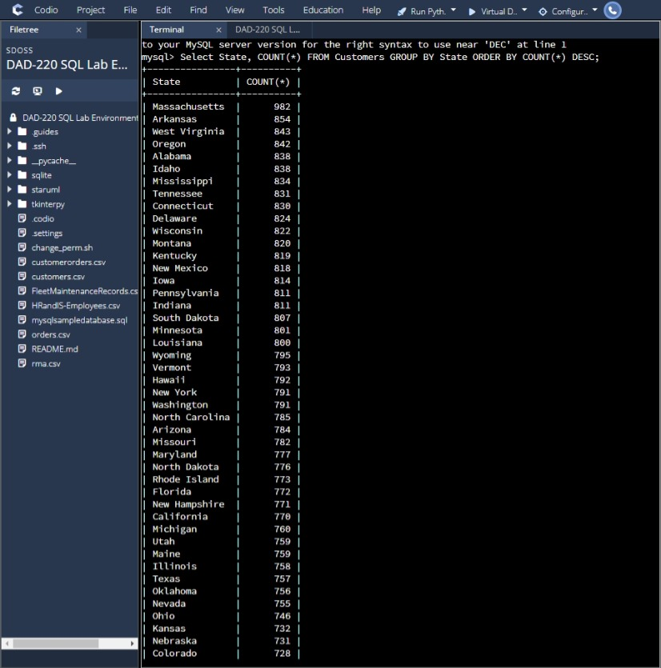

* + 1. Analyze the data to determine the top three products sold in the United States.

**BAS-48-1 C = 8385**

**ENT-48-40F = 6186**

**ENT-48-10F = 4329**

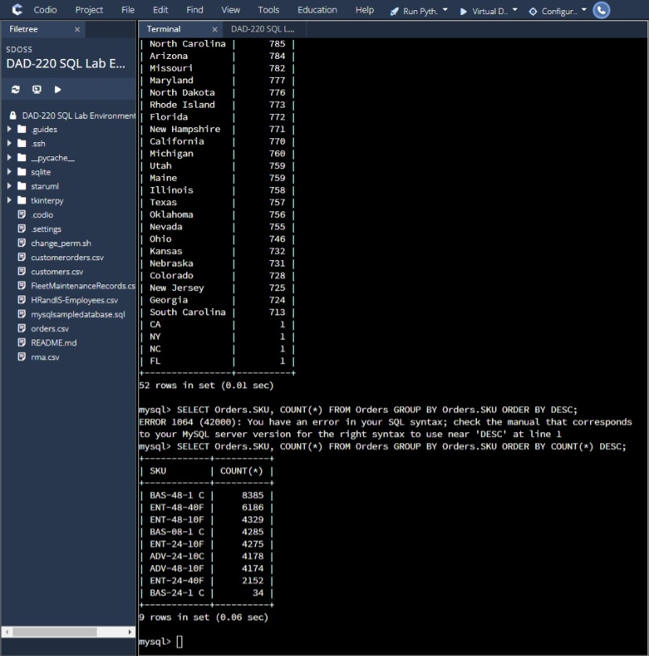

* + 1. Analyze the data to determine the top three products sold in the southeastern region of the United States.
       - Southeastern states to include in your analysis: Virginia, North Carolina, South Carolina, and Georgia

**BAS-48 – 1 C = 504**

**ENT-48-40F = 337**

**BAS-08-1 C = 257**

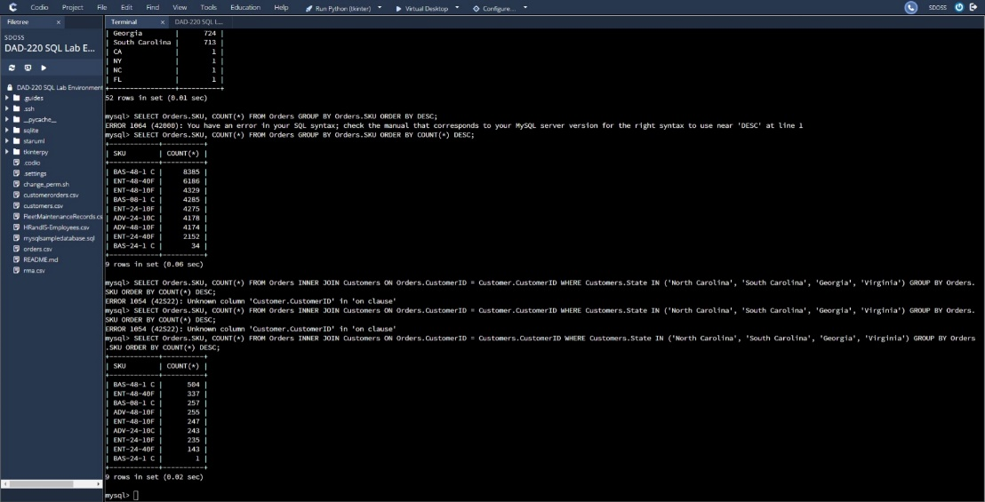

* 1. Returns by region:
     1. Analyze the data to determine the top three products returned in the United States.

**BAS-48-1 C = 8282**

**ENT-48-40F = 6118**

**ENT-48-10F = 4287**

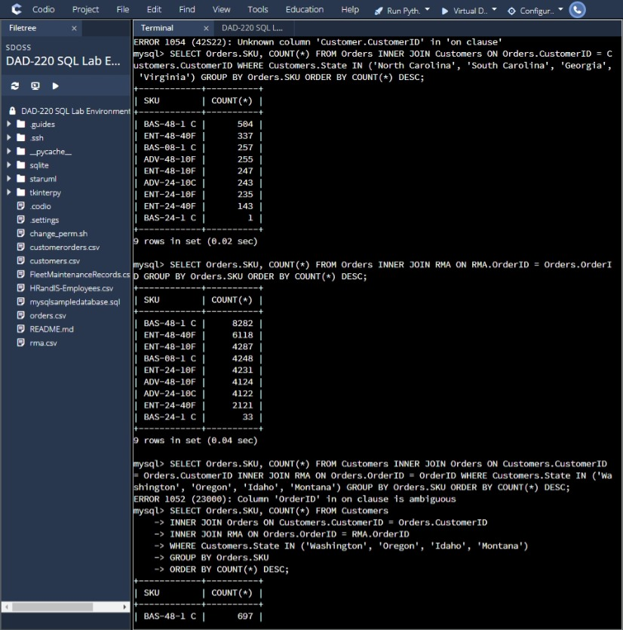

* + 1. Analyze the data to determine the top three products returned in the northwestern region of the United States.
       - Northwestern states to include in your analysis: Washington, Oregon, Idaho, and Montana

**BAS-48-1 C =697**

**ENT-48-40F = 534**

**BAS-08-1 C = 379**

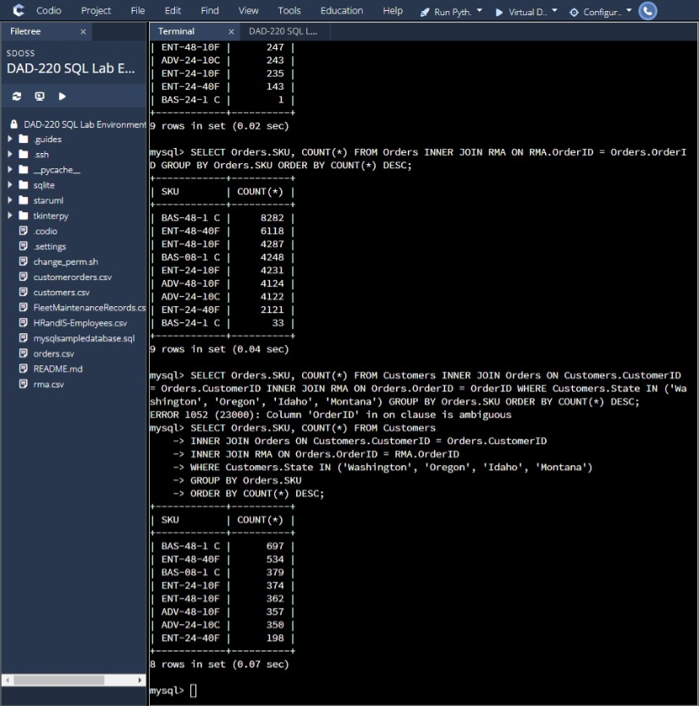

* Write an effective **summary of the analysis** of the captured data.
  1. Sales by region:
     1. Provide a well-written summary of your analysis on parts A through C.

I was able to pull data from the charts we have on file in order to find out which state has our largest customer base. Through my findings I was able to see from our customers table using a short query that our data has stated that Massachusetts has our largest customer base with a total of 982 customers. Also, with pulling data I was able to see the top three products being sold across the USA. Those top three products happened to be **BAS-48-1C** with 8,385 sales**, ENT-48-40F** with 6,186 sales, and **ENT-48-10F** with 4,329 sales. I was also able to pull from our southeastern region in order to give us insight on the top sales there. The top three products being sold were **BAS-48-1C** with 504 sales, **ENT-48-40F** with 337 sales, and **BAS-08-1C** with 257 sales.

* 1. Returns by region:
     1. Provide a well-written summary of your analysis on parts A and B.

Looking over the data on our returns by region I was able to use some queries to pull some data and come to finding over our state returns. Overall, in the USA the top three products we have being returned are **BAS-48-1C** with 8,282 being returned, **ENT-48-40F** with 6,118 being returned, and **BAS-08-1C** with 4,287 being returned. Along with this data I was able to pull from our northwestern region in order to see what is being returned most up there. I found that **BAS-48-1C** has 697 being returned, **ENT-48-40F** has 534 being returned and last, we have **BAS-08-1C** with 379 being returned in that area.

* Clearly **communicate your findings** to the Quantigration product manager by writing a report that explains your findings in a way nontechnical stakeholders will be able to digest and use.